**Strengthening Community Care: A Strategic Plan for Hillsboro County Home Health Agency**

Shaneka Gay, Sharanya Chinnigari, Tanaya Dutt, Zach Pitts

HLSV 5940.004 Capstone

Dr Kathleen Wiggins

December 09, 2024

|  |
| --- |
| **Table of Contents**  **Executive Summary.......................................................................................................................Page 3**  **Mission and Vision Statement......................................................................................................Page 4**  **Organizational Overview..............................................................................................................Page 4**  **SWOT Analysis..............................................................................................................................Page 9**  **Marketing Plan.............................................................................................................................Page 14**  **First Year Budget and Financial Projections............................................................................Page 32**  **Operations Plan............................................................................................................................Page 36**  **Quality Performance Indicators.................................................................................................Page 38**  **References.....................................................................................................................................Page 44**  **Appendix.......................................................................................................................................Page 47** |

**Executive Summary**

The Hillsboro County Home Health Agency (HCHHA) is a Medicare-certified nonprofit organization dedicated to providing quality, patient-centered home health services to Hillsboro's population. This strategic plan outlines actionable steps to strengthen community care, expand services, and improve operational efficiency while addressing challenges.

Key findings from the SWOT analysis identified HCHHA’s strengths, including a positive community reputation and its position as the sole provider of Medicare-certified home health services. However, challenges such as high nurse turnover and lack of digital presence, and reliance on government programs were also highlighted. Opportunities include establishing contracts with managed care organizations, leveraging healthcare technology and expanding service offerings to attract non-elderly demographics. Threats from increased competition and a stagnant economy emphasize the need for proactive strategies.

The marketing plan focuses on increasing strengthening community partnerships and patient engagement. Initiatives include digital transformation with an updated website, telehealth programs to improve accessibility, community outreach efforts, and partnerships with local providers to drive referrals. The first-year budget and financial projections prioritize sustainable growth while maintaining high-quality care. A shift towards value-based payment models, staff training programs, and cost-effective operational strategies ensures financial stability and improved outcomes.

To measure success, Quality Performance Indicators (QPIs) such as client satisfaction, unplanned hospitalizations and cost-effectiveness ratios will be implemented to monitor performance across HCHHA’s divisions.

Through this strategic plan, HCHHA aims to solidify its position as the leading provider of home health services in Hillsboro county, addressing the evolving healthcare needs of its community while enhancing accessibility, quality and operational efficiency.

**Mission and Vision Statement**

Mission: Hillsboro County Home Health Agency (HCHHA) strives to enrich the lives of Hillsboro county’s population by delivering accessible and value-based home health services that promote patient-centered care and quality of life.

Vision: To be Hillsboro county’s leading home health provider, known for our innovative practices, quality care and dedication to the health of every resident in our community.

**Organizational Overview**

**Home Health Services**

**Purpose:** To deliver skilled, medically necessary healthcare to individuals in their own homes, promoting independence and recovery while reducing hospital admissions.

**Scope**:

* + Home Health Services offer medical care and support to individuals who need assistance managing chronic conditions or recovering from surgeries or illnesses.
  + Common services include nursing care, physical therapy, occupational therapy, speech therapy, medical social services, and home health aide services.
  + Home visits are typically scheduled on a regular basis based on the patient’s needs and the physician's recommendations.

**Target Population**:

* + Older adults, individuals with chronic illnesses or disabilities, post-surgery patients, and those recovering from serious injuries.
  + Patients who are homebound or have difficulty traveling to a healthcare facility.

**Service Providers**:

* + Registered Nurses (RNs), nurse practitioners, physical/occupational therapists, home health aides, and social workers.

**Care Coordination**:

* + Care is coordinated with primary care providers, specialists, and other healthcare teams.
  + Electronic health records (EHR) and case management tools help ensure continuity of care and proper documentation of services rendered.

**Palliative Care**

**Purpose:** To provide relief from the symptoms, pain, and stress of a serious illness—whether or not it is terminal—focusing on improving quality of life for patients and their families.

**Scope**:

* + Palliative care is a holistic approach designed to provide relief from symptoms of serious illnesses such as cancer, heart disease, respiratory conditions, and neurological disorders.
  + It can be provided alongside curative treatments and focuses on managing symptoms such as pain, nausea, fatigue, and emotional distress.
  + Unlike hospice care, palliative care is not restricted to end-of-life situations and can be provided at any stage of a serious illness.

**Target Population**:

* + Individuals living with serious, chronic, or life-limiting conditions, such as cancer, heart disease, dementia, etc.
  + Families and caregivers also receive emotional and practical support.

**Service Providers**:

* + Palliative care teams include physicians, nurse practitioners, nurses, social workers, chaplains, and spiritual care providers, all of whom work together to offer comprehensive care.
  + Coordinated care involves collaboration with the patient’s existing medical team to ensure all aspects of the patient's well-being are addressed.

**Care Coordination**:

* + Emphasizes shared decision-making, helping patients and families make informed choices about treatment options, goals of care, and future plans.
  + Collaboration with specialty providers, case managers, and other healthcare professionals ensures holistic, patient-centered care.

**Hospice Care**

**Purpose:** To provide compassionate end-of-life care, focusing on comfort, dignity, and support for patients and families during the final stages of life.

**Scope**:

* + Hospice care is designed for individuals with a terminal illness and a prognosis of six months or less to live, based on physician assessment.
  + Services focus on comfort rather than curative treatments, addressing physical, emotional, social, and spiritual needs.
  + Key services include pain management, symptom control, emotional support, and bereavement counseling.

**Target Population**:

* + Individuals with terminal conditions, such as advanced cancer, heart failure, COPD, and progressive neurological diseases.
  + Families who need emotional, spiritual, and practical support during the end-of-life process.

**Service Providers**:

* + A hospice team typically includes physicians, nurses, social workers, chaplains, volunteers, and bereavement counselors.
  + The care team involves specialists in pain management, grief counseling, and chaplain services.

**Care Coordination**:

* + Hospice care is provided in the home, nursing homes, or inpatient hospice facilities.
  + Continuous support is available for patients and families 24/7, and care is adjusted based on changing needs during the final months of life.

**Community Health Services**

**Purpose:** To promote health and well-being within the community, with an emphasis on prevention, education, and access to care for underserved populations.

**Scope**:

* + Community health services include a broad range of programs and interventions designed to address public health concerns such as communicable diseases, vaccinations, health screenings, nutrition, mental health, and substance abuse prevention.
  + Services are tailored to the needs of specific populations, such as low-income families, seniors, children, and immigrants.

**Target Population**:

* + The broader community, with a focus on underserved populations or those at higher risk of health disparities (e.g., low-income families, racial/ethnic minorities, uninsured individuals).
  + Specific initiatives may target maternal and child health, chronic disease prevention, mental health support, and health literacy.

**Service Providers**:

* + Public health nurses, health educators, community health workers, nutritionists, mental health professionals, and substance abuse counselors.
  + Collaboration with local health systems, community-based organizations, schools, and government agencies is common.

**Care Coordination**:

* + Community health services often involve outreach and collaboration with other sectors, such as schools, housing authorities, and social services, to ensure that individuals have access to necessary care.
  + Public health initiatives may include immunization clinics, wellness checks, educational workshops, and health fairs.

**SWOT Analysis**

**Introduction**

In this SWOT analysis, we aim to elucidate the core strengths and weaknesses that make HCHHA what it is; we also hope to identify some possible threats and opportunities for HCHHA to act upon that could further strengthen its position in the community. Below is a table detailing all of those for HCHHA.

**Table 1. SWOT Table**

|  |  |
| --- | --- |
| **Strengths** | **Weaknesses** |
| * Established a positive reputation in the community. * Is the sole provider of Medicare-certified home health services. * Fully licensed and certified. | * The Home Care division is seeing high Nurse turnover. * Lacking an online or digital presence. * Restricted service area reach. * High reliance on government programs. |
| **Opportunities** | **Threats** |
| * Establish contracts with managed care organizations. * Strengthen local partnerships with healthcare providers. * Healthcare technology advancements present room for growth. * Expansion of current services offered to capitalize on the non-elderly demographic. | * Recent growth in competition for Home Care services. * Recent closures of Home Care agencies have seen an uptick. * A stagnant economy has stunted population and business growth in the Hillsboro area. |

**Strengths**

We begin by laying out the core strengths that HCHHA has that place it in an advantageous position in the Hillsboro County market. The first core strength we see from HCHHA is the positive reputation they have garnered thus far with the community. A good reputation is important for any healthcare provider. With the recent empowerment of healthcare customers, it is now easier than ever for individuals to search and compare quality care (HealthManagement, 2016). By already being held in a positive light by the community HCHHA can further expand its share of the Hillsboro County market. The second strength HCHHA boasts is its being the sole provider of Medicare-certified home health services. This, again, functions to secure another portion of the market for HCHHA. Of the 141,435 individuals in Hillsboro County 19,964 of them qualify for Medicare as of 2014 (Seidel, L. F., & Lewis, J. B. 2022). By being the only Medicare-certified provider of home health services, HCHHA is positioned as an attractive option for those seeking home health services. Finally, HCHHA is fully licensed and certified for all the services it provides and its operation in Hillsboro County. This allows HCHHA to fully focus its efforts on not only providing quality care but also offering an abundant array of care options to the individuals seeking their services in Hillsboro County.

**Weaknesses**

It is also important that we look at and identify the weaknesses that are holding back HCHHA. One startling trend is the high rate of turnover among nurses working in the Home Care Division. This puts the quality-of-care HCHHA can provide in jeopardy as the turnover makes attaining an ideal nurse-patient ratio difficult. A second weakness identified would be the lack of digital and online presence of HCHHA. This lack of online presence can present itself as a barrier to access for some potential customers. Many healthcare consumers, with information available at their fingertips due to the internet, have become empowered due to online information when it comes to their healthcare (Madappady, 2024). A third weakness found in this would have to be the restricted service area reach which constrained HCHHA’s ability to provide care and in some cases acts as a barrier to access for some customers. HCHHA has seen criticism from the Middleboro Sentinel alluding to the location of HCHHA’s operations being on the edge of the county, making it difficult for some to access the care HCHHA has to offer (Seidel, L. F., & Lewis, J. B. 2022). The last weakness we see in HCHHA would be the organization’s heavy reliance on government programs. All the services offered under HCHHA’s Home Care Division banner are covered under Medicare and Medicaid, however, the Community Health Division has to rely on state and local grants to budget for its operations.

**Opportunities**

After delineating the strengths and weaknesses that give HCHHA’s current market position it is important to look at burgeoning opportunities HCHHA can act upon to strengthen itself in the community and financially. The first opportunity HCHHA should look to seize would be negotiating and contracting with managed care organizations (MCO). Martha Washington, HCHHA’s executive director, has expressed her worry concerning the organization’s reliance on government programs despite the successful efforts made to contract with managed care organizations (Seidel, L. F., & Lewis, J. B. 2017). There has also been increased interest in using home care services by insurers and MCOs. HCHHA could act upon this opportunity to engage and negotiate with MCOs to widen the range of their market share and increasing the level of access to the services their Home Care Division has to offer, all while reducing their dependence on government programs for business. A second opportunity that HCHHA should consider pursuing would be to increase partnerships with other local healthcare providers. By forming partnerships and strengthening relationships among other healthcare providers in the community HCHHA could further expand their brand and increase the quality of care they can provide (Daniel Casciato, 2019)**.** Not only would HCHHA see an increase in its market share, but it could also utilize the labor forces of other providers in the areas to meet the growing demand for nurses. The healthcare environment and marketplace are always changing and so is the technology available for providers. HCHHA has made steps towards implementing new technology to improve the services they provide, an example of this would be the electronic medical record and patient care planning system implemented upon the appointment of Martha Washington (Seidel, L. F., & Lewis, J. B. 2022). However, it is important for HCHHA to continually be up to date with the technological advancements being made in the healthcare field, whether it is information management systems like those Martha Washington implemented or new medical devices and techniques. This will ensure that HCHHA is at the forefront of providing up-to-date and quality care to its constituents. The final market opportunity we identified for HCHHA would be the expansion of the other services they have to offer the community. The Home Care Division has a large focus, however, HCHHA has a handful of other divisions that once fleshed out could offer great lateral market penetration for the organization. One great example of this would be focusing on the expansion of HCHHA’s Community Health Division to meet the broader demand of Hillsboro County individuals’ needs. When considering the more rural nature of Hillsboro County, the geographical barrier to care is one that HCHHA can seek to eliminate. By expanding the services offered HCHHA can become an attractive choice for a multitude of services and by doing so they could widen the net of their market capture.

**Threats**

To conclude the SWOT analysis, we will review the external threats currently facing HCHHA. The first threat identified would be the growing competition inside the home care field, specifically Martha Washington expressed concern over a national home care company expressing interest in the Jasper market (Seidel, L. F., & Lewis, J. B. 2022). HCHHA and its homecare division have built up a great reputation from the many years of quality service they have provided the community, however, it will be important for HCHHA to continue to be the number one choice for home care services in Hillsboro County when more healthcare providers begin to move in and offer similar services to theirs. One suggestion made in the opportunities could help do just that, by negotiating contracts with managed care organizations HCHHA can become more accessible on top of the already large Medicare traffic they currently pull in. In contrast to growing competition, there have also been trends of home care agencies closing businesses or merging to stay viable and in business (Seidel, L. F., & Lewis, J. B. 2022). It is important for HCHHA to find ways to stay viable and in business for the Hillsboro County community. It has been mentioned that the Home Care Division takes a large share of the focus in HCHHA, however, as mentioned before it would behoove HCHHA to expand upon and improve the other services they provide to meet the wide range of demands from the diverse age demographics in Hillsboro County. Not only would this increase their lateral market penetration, but it diversifies HCHHA's revenue streams from relying too heavily on the Home Care Division. Finally, it is important to take note of the recent economic struggles that have affected Hillsboro County. Fifteen years prior Hillsboro County had been hit with a major flood that did extensive damage to the Carlstead Rayon Corporation’s production facility (Seidel, L. F., & Lewis, J. B. 2022). Instead of reopening Carlstead took the insurance policy to open a new facility located outside of Hillsboro County, taking with it the many jobs it offered as well. A strong rural economy paired with competent healthcare systems helps address two of the social detriments of health, those being economic stability and healthcare access (RHIH, 2024). With a lagging rural economy, more stress is placed on HCHHA to ensure Hillsboro County residents can access and afford their healthcare services. HCHHA can work together alongside other local healthcare providers to ensure residents have a broad spectrum of their needs covered. Not only this but as mentioned before HCHHA could negotiate contracts with managed care organizations to further expand the access and affordability of their services.

**Marketing Plan for HCHHA**

**Executive Summary**

The Hillsboro County Home Health Agency (HCHHA) is a nonprofit healthcare organization that is growing continuously to provide innovative home care services for the people of Hillsboro County particularly, to the people who prefer home care services and predominantly to the elderly population and people with the chronic conditions, terminal illness by offering various kinds of home care services that include senior health clinics, telehealth programs, personalized care to meet the demands of the senior population as well as individuals with chronic conditions or those recovering from surgery who prefer receiving care from their own homes. The below marketing plan helps strengthen its position in Hillsboro County by increasing client referrals, increasing patient satisfaction by using digital innovative methods making its strong presence online and social media, and including various strategies like community outreach through seminars as well as partnerships with local healthcare providers, provider referrals, social media campaigns, increasing awareness and building strong relationships with stakeholders, partnering with the managed care organizations to increase more patients through their patient referral programs and focusing on strengthening its branding by providing high-quality home care services without compromising in quality care provided by focusing on value-based care. To increase trust among the patients with customer satisfaction surveys and client success stories building credibility as well the pricing strategies will include service bundles and discounts to attract new clients while maintaining competitive rates to ensure sustainability. By implementing these strategies, HCHHA aims to solidify its position as the top choice for personalized, quality home healthcare services in Hillsboro County eventually addressing the needs of its aging population and enhancing overall community health outcomes.

**Introduction** This marketing plan highlights how the Hillsboro County Home Health Agency (HCHHA) evolved and how it can stand as an alone provider of home care services, private duty services, Hospice and palliative care services in the county as there is greater demand for various home healthcare services with the increase in aged population demographics across Hillsboro County and our marketing plan with various strategies helps the HCHHA to stand as the standalone provider of home healthcare services by analyzing the target market and to withstand future competitors by providing various services by hiring qualified staff to provide homecare services that meet demands of senior care population in the county, though it provides various homecare services to the population, our marketing plan will be currently focusing on providing various kinds of innovative and quality home care services meeting the current market needs and position the HCHHA as one of the top providers of home health services.

**Company Analysis**  The Hillsboro County Home Health Agency is the only Medicare-certified home health agency in Hillsboro County and was founded in the year 1946 It was originally named Middleboro Home Health Agency and evolved continuously to provide home health services to the people of Hillsboro County and It is renamed as Hillsboro county home health agency to be more reflected across the county and it provides full home health care services that include skilled nursing, physical therapy, and chronic illness management to the people of Hillsboro County and private care services like daily activities, in-home services, nursing care, social services, etc,Hospice and palliative care services with highly dedicated certified professionals, Hillsboro County Home Health approaches all your health concerns with compassion, care, and dedication. Being Medicare-certified and the Joint Commission accredits home health agency pays keen attention to full compliance with strict industry standards as well, thus rendering reliable and quality services (Lewis & Seidel, 2022). The organization's marketing style is a traditional marketing strategy that involves referrals and community outreach, with very little online presence. Our customer insights have identified that there is a huge demand for accessible care at home, especially by elderly patients who desire independence and continuous care. Hillsboro County Home Health operates in a highly competitive environment as the demand for home healthcare services increases may also increase competition from new entries into the market like private healthcare agencies as well as local hospitals.

**Market Definition, Potential, and Demand**

***Target Market***

The primarymarket for the HCHHA is the homecare division mainly from the senior population older than 65 years of age who are receiving care from the home and the estimated increase in the aged population 65 and older is not only in the county but in the entire country is projected to rise more by 2030 (US Census Bureau, 2021).As they are the primary target population the demand for home care services, personalized care services, Hospice and palliative care services also increases as they are more comfortable with home care as more of the senior population is served and discharged by the county the target population of our market will be the aged population and the people who are looking to take care for various services from home but the majority of the patients procuring various kinds of home care services that may be personalized care services, rehab services, chronic disease treatments, providing care for the patients with the serious illness, nearing to death from home with comfort,etc (Seidel, L. F., & Lewis, J. B. 2022).

**Figure 1** *A graphical representation of the patients currently served by the home health agency and patients discharged in past 12 months*

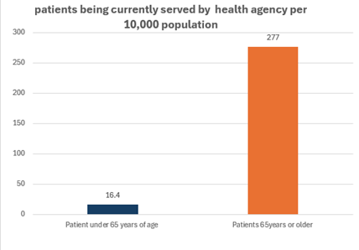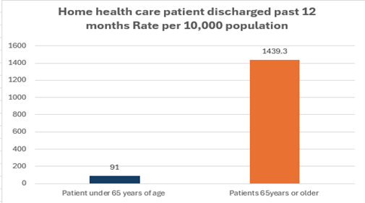

*Note:* The above picture is a graphical representation of the patients currently being served by the home health agency and patients discharged by the home health agency in the past 12 months most of them are over age 65 by taking the values from the book (Seidel, L. F., & Lewis, J. B. 2022).

***Market Potential and Growth*** Home health services demand has enormously increased in the county with the increase in the aged population in the county and the increase in chronic conditions and age-related issues with the patients currently served in homecare services most of them are aged population and the US home market is estimated to grow tremendously in future years with the same way (U.S. Home Healthcare Services Market Size | Growth [2032], n.d.). The home health market is projected to grow more in Hillsboro County with the projected increase in the aged population. By meeting the demands the agency strives to provide efficient care to these populations by using telehealth services to make it easily accessible to them and by providing skilled staff like nursing services, therapy services, and support for them in curing chronic illness and other aged diseases. By making all these the Hillsboro home market is projected to increase its revenue in the coming years.

**Figure 2**

*Projected increase in home health market in the US market* *(U.S. Home Healthcare Services Market Size | Growth [2032], n.d.)*

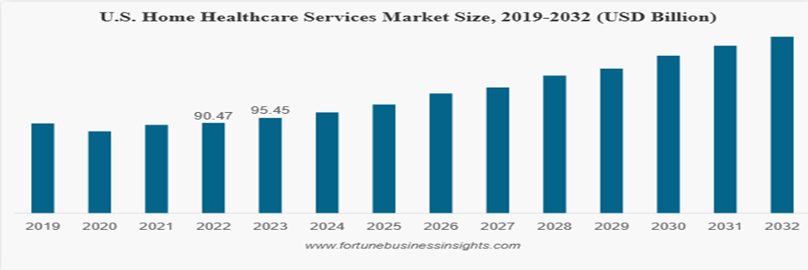

*Note:* The above image shows the predicted increase in the home health market in the USA for the coming years.

***Licensing and Staffing Requirements***  To operate effectively in this market, maintaining proper licensing and staffing is essential. Hillsboro County Home Health Agency obtained all the state and local licenses as required by the law to comply with standard regulatory standards. As a Medicare-certified home health agency and Joint commission accreditation, it complies with federal regulations and standards. A team of licensed professionals, which includes registered nurses and certified home health aides, are trained to meet and comply with rigorous industry standards. Such commitment towards regulatory compliance and competent staffing makes the agency more competitive in the market. The agency will be able to give safety, and quality care to the elderly of Hillsboro County that meets their needs and expectations (Seidel, L. F., & Lewis, J. B. 2022).

**Competitor Analysis** With the increase in demand for home health services in the county there is a huge increase in the competition for the agency with the new entrants into the market and with the existing healthcare organizations in the county like Medical Associates, Middleboro Community Hospital, Physician Care Services, Inc., Webster health system, Jasper Gardens Nursing Home could possess the competition to the agency by launching the new home health services individually or by partnering with other organization and these organizations could possess a high to low competition to the agency that could help the agency to develop strategies by analyzing the challenges possessed by these organizations and by collaborating with some of them to benefit mutually and decrease the competition.

***Medical Associates***

It is a private medical organization that provides a variety of outpatient services with a group of 40 physicians, and it has a good reputation in the county for its services like chronic disease management, internal medicine, and pediatrics its main specialty is bringing a group of specialized physicians from the group of hospitals like Middleboro community hospital and capital city general hospital though it doesn’t provide home services but with the growing demand It may start collaborating with other healthcare organizations to start home care services with its strong referrals but for the Hillsboro home health agency it could posses a challenge and a good opportunity. It could be a competition if it starts the homecare services in the county by partnering with the other healthcare organizations in the county and It could also be a great opportunity if the HCHHA could partner with them to increase the patients through its strong referral network (Seidel, L. F., & Lewis, J. B. 2022).

***Middleboro Community Hospital***

Middleboro Community Hospital is a nonprofit hospital with various accreditations from the state-licensed, US Department of Health and Human Services for participation in Medicare, and Blue Cross Blue Shield participation by providing outpatient services to patients in the county. It provides a wide range of inpatient and outpatient services. It is not primarily into home care services, but it provides short-term post-care to discharged patients but not long-term home care services. HCHHA has the slight advantage of its long-term home care services provided to the senior population. By considering the increased demand for home care services in the county the Middleboro Community Hospital could start a long-term home care sector that could be strong competition to the HCHHA because of its strong reputation and existing patients may prefer this in the future. HCHHA should always monitor the new entrants and stay ahead of them by personalizing services (Seidel, L. F., & Lewis, J. B. 2022).

***Physician Care Services, Inc.***

Physician Care Services, Inc. is a for-profit health organization that provides non-emergent care services to the people of the county compared to other organizations it is slightly less competitive with the HCHHA because not only it doesn’t provide home care services but also it doesn’t support chronic diseases treatment as the aged population requires long-term support that is not provided by physician Care Services, Inc (Seidel, L. F., & Lewis, J. B. 2022).

***Webster Hospital***

Webster Hospital is a non-profit hospital that provides in-patient services by meeting the conditions of Medicare and Medicaid Services and other insurance organizations. It provides osteopathic services as it is associated with Osteopathic Hospitals of America, though it doesn’t provide home care services launching the new home health services could attract people who are seeking post-acute care but HCHHA can sustain the competition as it provides continued care required to address the chronic aged diseases (Seidel, L. F., & Lewis, J. B. 2022)***.***

***Jasper Gardens Nursing Home***

The Jasper Gardens Nursing Home is a for-profit healthcare organization owned by Jefferson Partners, LLC. It is located near the Medical Associates and it provides outpatient services like nursing and rehabilitation services as it is also a Medicare-Medicaid certified nursing home service in its community but it could be slightly competitive to the HCHHA as it provides the services required by the senior population but at its facility, as the increase in demand it could start partnering with medical associates to provide home health services to the senior population but HCHHA can collaborate with them for the senior patients who require continuum care for the chronic diseases as Jasper nursing home doesn’t provide chronic disease treatment (Seidel, L. F., & Lewis, J. B. 2022).

**Customer Analysis**

The major customers of Hillsboro Health considering the utilization statistics provided in the book include the majority of older patients and chronically ill patients, people recovering from chronic diseases, post-acute care patients, and patients with chronic diseases like heart diseases, cancer, respiratory diseases that require various kinds of home care services for the people who are Medicare, Medicaid, and other private insurance certified people from various communities in the county but the majority from the Middleboro community and other communities in the county. From year to year, the utilization of home services is increasing with the demand, and the Hillsboro Health Agency is always updated with the needs of the customers it serves if we consider in the pandemic many people refused coming to home to serve them started telehealth services with the qualified staff licensed practical nurse, physician, occupational therapist, personal care attendant, physical therapist, registered nurse, speech therapist, social workers that provide care meeting for the demand of its customers.

**Figure 3**

*Graphical representation of customer age that the Hillsboro home health Hospice Patient Age at Time of Admission by taking the values given from the book for the year 2024* *(Seidel, L. F., & Lewis, J. B. 2022).*

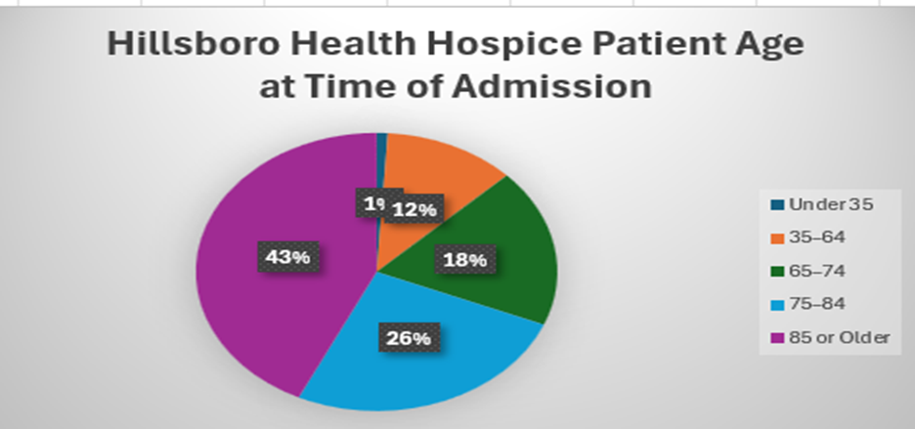

*Note:* The above graphical representation shows that most of the customers are aged that receiving services from Hillsboro Health Hospice and these values are taken from the utilization statistics given in the book (Seidel, L. F., & Lewis, J. B. 2022).

**Figure 4**

*Graphical representation to show the total number of overall home care visits from the year 2022 to 2024 by taking the utilization statistics given in the book* *(Seidel, L. F., & Lewis, J. B. 2022).*

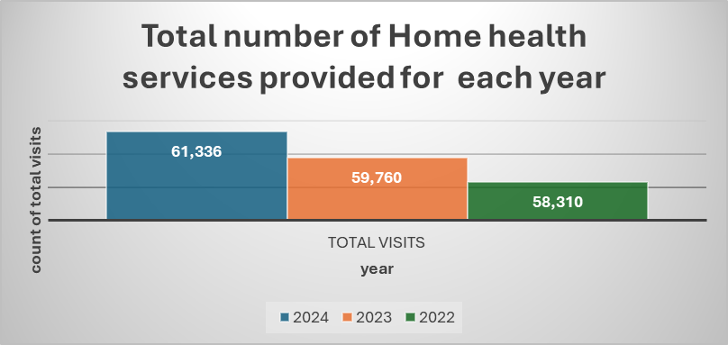

*Note:* The year-wise prediction of Hillsboro Health providing home services for the county

**Figure 5**

*Graphical representation of the Hillsboro health home services utilization city-wise in the Hillsboro community and the values taken from the utilization statistics from the book (Seidel, L. F., & Lewis, J. B. 2022).*

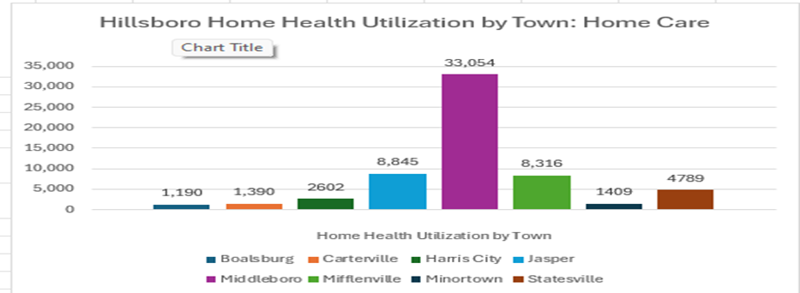

*Note:* Middleboro is the first highest, with most customers or patients receiving home services from Hillsboro Health based on the utilization statistics in the book (Seidel, L. F., & Lewis, J. B. 2022).

**Marketing Goals and Objectives**

The below-listed marketing goals help Hillsboro Health to position itself as a leader in providing Quality home health services and to sustain future competitors in the county.

**Figure 6**

*A pictorial representation of marketing goals, objectives, achievable, and time taken to achieve goals.*

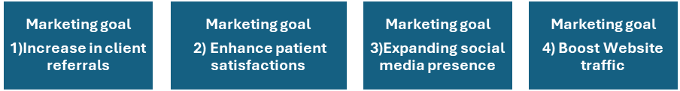

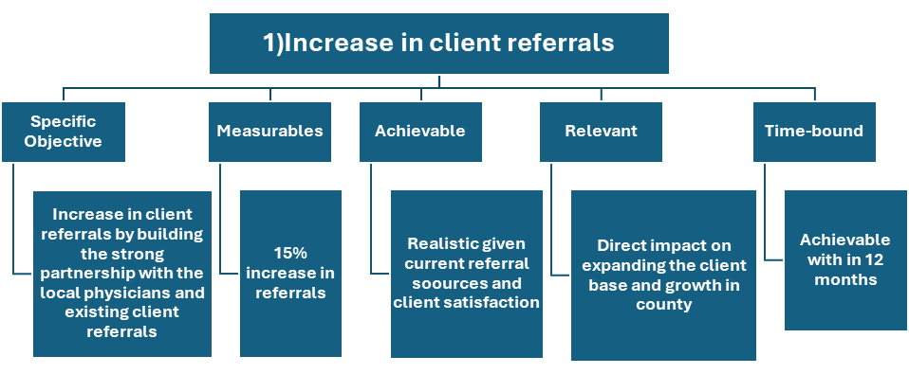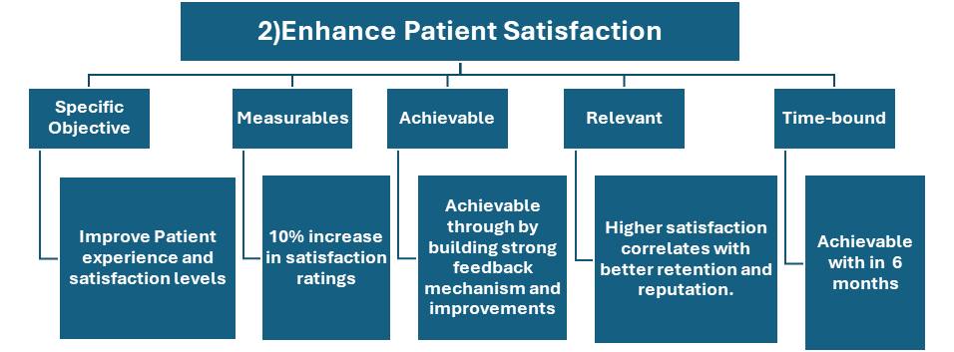

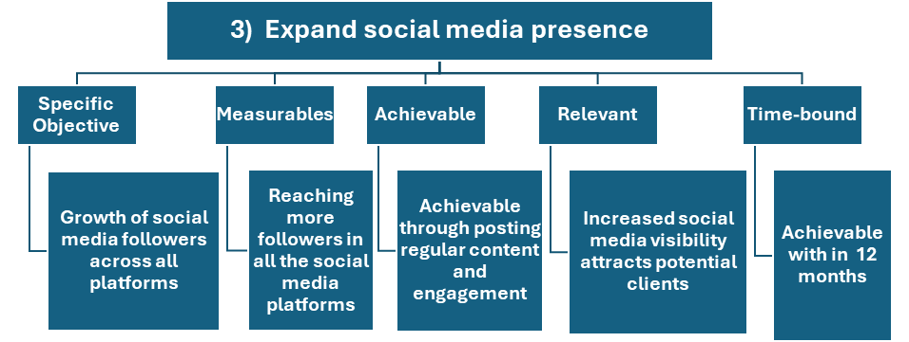

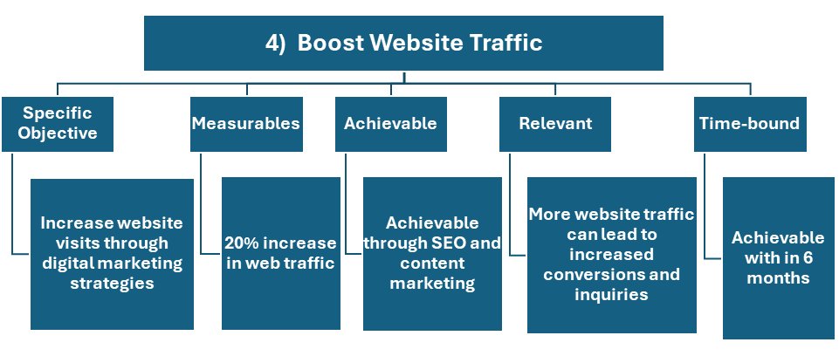*Note:* For the four marketing goals I have created a separate image to show a clear objective, measurables, achievable, relevant, and time required to achieve the goals*.*

**Marketing strategy**

To expand the Hillsboro Health market in the entire county as some places in the county other than Middleboro, Jasper, and Mifflenville have less utilization of home care, private duty services, Hospice care, and other services so the below mentioned strategies help the Hillsboro health to increase its presence in other cities and making it as the leading provider of home services in the county.

**Figure 7**

*Pictorial representations of the Marketing strategies with the estimated budget and clear objective.*

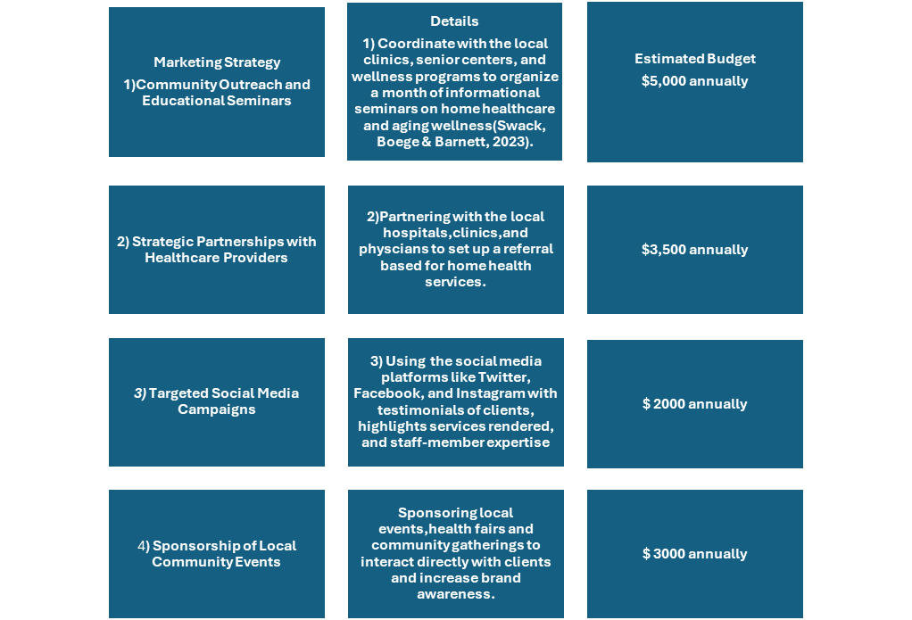**Target Market**

The target market for Hillsboro Health is the patients preferring health services from their homes in Hillsboro County and with the projected increase in the elderly population aged more than 65 along with the people with chronic conditions, post-operative patients, critically ill patients, patients with a terminal illness, patients seeking care in their final weeks these are our target population and the agency will provide different type of home services required for our target population, addressing the unique needs of each of our target population by providing comfort and quality care from their homes by meeting the Medicare standards (Seidel, L. F., & Lewis, J. B. 2022). Additionally, family caregivers need professional help like high-end treatments for the patients that will be provided by our agency.

**Positioning**

Hillsboro Home Health is highly dedicated in providing quality and patient-centered, sensitive, skilled, and customized in-home healthcare services to meet the needs of our target population by ensuring they meet the standards of Medicare. Our agency strives to meet the unique needs of our target population and a trusted alternative hospital-based environment for the target population with chronic conditions and severe conditions. Qualified staff like nurses, physicians, and other staff of the agency ensure the target population receives their desired care without compromising on quality and comfort.

**Product and Brand Management**

To establish HCHHA as a leading provider of home health services in Hillsboro County and to withstand future competitors by ensuring the growth of its services in the entire county by expanding the customer base.

***Tactics***

Increasing the digital presence with a newly updated website with a fresh logo and including all the services offered, success stories to attract new clients, easy navigate features to book the services helps in achieving to increase more customers from other cities in the county. Implementing regular feedback tracking mechanisms and monitoring more accurately helps improve the services provided and helps in retaining existing patients (Hoben et al., 2017). Community outreach programs help increase partnerships with local providers and increase senior patient referrals to our agency. To retain quality and agency trust the HCHHA should provide continuous training to the staff and by launching incentive programs for employees to overcome the employee turnover rates in organizations.

**Pricing Management**

The pricing management for Hillsboro Health is maintaining a sustainable pricing structure by maintaining quality care to minimize its funding limits and implementing value-based payment models by ensuring compliance with healthcare regulatory requirements, improving patient outcomes, and improved coordination between the clinical and administrative teams to help minimize the financial loss. Tactics include focusing on shifting from a fee-based payment structure to value-based payment models and developing the metrics to measure performance and compliance with Medicare standards (Expanded Home Health Value-Based Purchasing Model | CMS, 2022). Implementing the tiered pricing structure that offers different levels of service packages to meet the patient's demand. Investing in technology to improve the streamlined process between the clinical and administrative departments to minimize financial loss.

**Distribution Management**

The distribution objective for Hillsboro Health is to increase more accessibility of health services in all the regions of Hillsboro County by using digital innovations like telemedicine to reach out to places in the county other than Jasper, and Middleboro cities. Tactics like utilizing telemedicine services and it is evident that customer reach is increased as it provides greater accessibility (Barbosa et al., 2021). The agency should utilize more telemedicine services to increase its customers in other parts of the county and help to provide care in a short time without compromising on quality. Partnering with the local hospitals and providers to increase local patients through referrals.

**Communication Management**

Effective communication is important in connecting with clients for our Hillsboro home health goal of communication is to establish strong relationships with our stakeholders' patients, providers, and nurses through various engaging ways to build transparency and trust among the stakeholders. Tactics include publishing monthly newsletters regarding services, health tips, and updates about the agency and updating them in the online portal that includes regarding services, health tips, and updates about the agency and using real messaging tools to communicate with the patients about the updates on patients health status reducing the response time for patients (Embry & Embry, 2024). All these help in effective communication.

**Implementation and Control**

**Table 2**

*Detailed Tabular description of Implementation and Control*

|  |  |  |  |  |
| --- | --- | --- | --- | --- |
| **Action Plan** | **Responsible Party** | **Timeline** | **Budget** | **Metrics** |
| Social Media Campaign | Marketing Manager | Start Q1 | $8,000 | Follower growth, engagement growth, website traffic |
| Community Partnerships | Community Outreach Coordinator | Start Q2 | $12,000 | number of referrals, partnership feedback |
| Patient Referral Program | Sales and Referral Manager | Start Q1 | $5,000 | Number of referrals, conversion rate, feedback from referred patients |
| Health Seminars and Workshops | Community Relations Manager | Start Q2 | $6,000 | Attendance numbers, patient inquiries |
| Mobile Care Units | Operations Manager | Start Q3 | $20,000 | Service coverage area, patient satisfaction |
| Employee Training Program | HR Manager | Start Q1 | $3,000 | Training completion rate, employee satisfaction |
| Telemedicine expansion | Operations Manager | Start Q1 | $4,000 | Telemedicine utilization rate, patient satisfaction |
| Branding Overhaul | Marketing Team | Start Q2 | $7,500 | New brand recognition, customer feedback |
| Local Media Advertising | Marketing Director | Start Q3 | $10,000 | Reach, lead generation, media impressions |

**Services Offered**

Hillsboro County Home Health Agency (HCHHA) provides a comprehensive range of services to meet the needs of the population in Hillsboro County. HCHHA spans over multiple divisions: the home care division, Private Duty Division and Community Health Division. These services are ensured to be high-quality and patient-centered while improving quality of care for their clients.

The Home Care Division focuses on skilled medical and therapeutic services tailored to clients recovering from injury, illness or surgery or managing chronic illnesses. These services include nursing services such as registered nurses and licensed practical nurses providing medical care such as health monitoring, medication administration and patient education. Physical therapists are also a part of the home care division. They assist clients in improving mobility and strength through therapeutic exercises. This division also provides pediatric services to children who are prematurely born, or are recovering from surgery, or going through a chronic condition.

The Private Duty Division assists patients with daily activities like nursing care and medication and blood pressure screenings. The Private Duty Division provides services like companionship and homemaking services and personal care services. For personal care services, clients are provided with personal assistance with daily living as well as respite services. Companion and homemaking services include trained staff for light housekeeping, grocery shopping and similar household duties.

The Community Health Division at HCHHA includes a telehealth program, maternal and child health program, high blood pressure screening program, community health activities program, senior health clinics and head lice program (Seidel, L. F., & Lewis, J. B. 2022).

**First-year Budget and financial projections**

The following budget estimates first-year expenditures and income for a large county home health agency and hospice (Hillsboro County Health Agency and Valley Hospice). This budget includes startup expenditures, predicted monthly and annual running costs, and expected revenue based on patient volume and service price.

For a detailed breakdown of the start-up costs please refer to Appendix I: Start-Up and Annual Expense Worksheet at the end of this document.

**Startup Costs**

Startup costs are one-time expenses to start a healthcare practice. These $199,000 startup costs include critical business activities.

**Legal, Accounting, and Professional Services**: $5,000 covers legal and financial consultation expenses for business registration, contract review, and initial financial statements. Such expert services assure early compliance and financial soundness.

**Advertising and Promotions**: This line spends $20,000 on advertising and promotions to attract customers. These costs include web marketing, print ads, and a grand opening.

**Deposits and Utilities**: The estimated $500 utility deposit covers electricity, water, and other services.

**Licenses and permissions**: Operating a healthcare establishment requires $3,000 in permits and permissions.

**Prepaid Insurance**: Healthcare facilities need buildings and liability insurance to reduce hazards. The first $10,000 prepaid insurance fee covers general liability, property, and malpractice.

**Furniture, Fixtures, Equipment, and Improvements**: $18,000 is planned for furniture, fixtures, equipment, and improvements. **Breakdown**: $3500 for furniture, $3500 for fixtures, $7500 for equipment and $4000 leasehold improvements.

**Truck & Vehicle Costs**: $3,000 covers the use of a vehicle for patient visits, supply transport, and external appointments.

**Starting Inventory:** This budgeted line provides $13,000 for medical supplies, durable medical equipment (DME), and other consumables needed for providing in-home care or hospice services.

**Cash (Working Capital):** The amount of capital a business needs to cover its day-to-day operational expenses, such as payroll, inventory, accounts receivable, and other short-term liabilities. These combined costs provide the foundation for the practice's launch, totaling $54,000.

**Estimating Sales Revenue**

Patient volume, frequency, and average appointment charges determine income projections. This healthcare practice expects 1000 patients per year, an average of twenty visits per month at $200 per visit. This calculation estimates $4,000,000 in annual revenue (1000 patients x 20 visits x $200 per visit). This estimate sets first-year financial targets and benchmarks to drive spending and profitability. As the practice grows its patient base and services, revenue is expected to grow 10% annually to $ 4,400,000 in the second year and $4,840,000 in the third.

For a detailed breakdown of the Annual Sales and Earnings, please refer to Appendix J: at the end of this document.

**Regular Monthly and Annual Expenses**

To maintain efficient operations and high-quality care, regular monthly and annual expenses are carefully estimated. Monthly payments are estimated at $57,000, equating to $684,000 annually. Key expense categories include:

**Salaries and Wages**: The main monthly expenditure is salaries and compensation, predicted at $36,000. To ensure high-quality patient care, healthcare providers and administrative workers receive competitive pay. To retain qualified workers, salaries rose 10% from $432,000 to $475,200 in the second year to $217,800 in the third year.

**Rent**: This will amount to $3,000 per month, $36,000 annually. This cost represents the necessity for enough space for exam rooms, offices, and waiting spaces. Market-rate annual gains are expected.

**Insurance**: Approximately $250 per month or $3,000 annually covers liability and property insurance, protecting the practice from dangers. These insurance costs rise 10% annually.

**Utility, Telephone, and Internet**: $600 per month for utilities, telephone, and internet. These costs cover fundamental services to keep businesses running.

**Professional Fees, Supplies, and Maintenance**: $1,000 a month covers basic supplies, maintenance, legal, and accounting fees. These expenditures support compliance, equipment maintenance, and regulatory compliance, guaranteeing smooth operations.

**Loan Repayment**: Start-up loans require $1,000 monthly or $12,000 annual payments for principal and interest. This payment schedule reduces initial debt and manages cash flow for the practice.

**Projected Net Profit**

Based on revenue projections and predicted annual expenses, the practice's first-year gross profit should be $2,000,000. The expected first-year net profit is $1,185,294 after $814,076 in yearly expenses. This is a strong net profit margin for the agency’s first year. The positive net profit suggests the agency will generate a profit in its first year. The agency will focus on reinvesting profits to grow the business, enhance services, or improve operational efficiency.

Revenue growth and managed spending increases are expected to boost net profit to $2,202,346.40 in the second year and $2,350,931.68 in the third. The agency’s financial stability and growth potential are rising as early revenues are spent on expansion and service excellence.

**Operations Plan**

**Patient Care Objectives**

To ensure HCHHA tailors their care to be centered for the patients it is important that HCHHA actively engages them during the decision-making process. One big part of this would be active education to make the patients more informed on what is available to them and how their conditions affect them. Most chronic disease management begins at home for the patients by living an informed lifestyle (Adams, 2010) and reducing risk and exposure to activities or substances that could worsen their conditions. It is also important to communicate and ensure patient satisfaction when it comes to the services provided by HCHHA. Customer satisfaction data can be generated through the use of post-visit feedback forms. This further engages patients in helping customize the care that they receive. By utilizing these feedback forms HCHHA can ensure they are doing all they can to create a patient-centric model.

**Healthcare Regulation Compliance**

It is important for HCHHA to continually educate and train their workforce. This not only keeps HCHHA employees safe but also ensures patients are receiving quality care. This training extends from safety and hazard protocols to even learning new healthcare techniques and technology. HCHHA should set aside time every quarter to evaluate and update their training to ensure it is up to date OSHA requirements would require healthcare organizations like HCHHA to provide appropriate and ample personal protective equipment (PPE) (OSHA, 2023). HCHHA should make PPE readily available to its employees as well as training staff on its proper use cases and how to effectively utilize PPE. Again, this will ensure that HCHHA employees and patients are safe and receiving quality care. Finally, HCHHA needs to concern itself with healthcare regulations like HIPAA and protected health information (PHI). PHI should maintain a level of anonymity unless patients give expressed consent otherwise (Isola & Khalili, 2023). With the recent implementation of electronic health records, HCHHA must ensure their patients’ data is secure to stay in line with HIPAA requirements.

**Resource Management**

One major problem HCHHA has been dealing with would be the high nurse turnover rates working in the Home Care Division. It is essential for HCHHA to ensure proper staffing of nurses to provide quality care. Nurses are the backbone of healthcare and often do a majority of the visiting and caring for ill patients (Ighani, 2024). HCHHA should strive to maintain at least a one-nurse-per-ten-patient ratio to ensure patients are receiving the care they deserve while also avoiding overworking nurses. HCHHA currently has two office locations one facility in Jasper and their main offices in Middleboro. While the Middleboro office has seen good utilization, Catherine Newfields, the Home Care Division manager, has been frustrated with HCHHA’s lack of presence in Jasper (Seidel, L. F., & Lewis, J. B. 2022). The hospitals in Capital City have regularly been referring patients to Capital City Visiting Nurse Association instead of HCHHA’s Jasper location (Seidel, L. F., & Lewis, J. B. 2022). HCHHA should make strides towards regaining the market capture of Jasper residents and fully fleshing out their Jasper practice to ensure they are maximizing the potential of both their locations.

**Administrative and Clinical Processes**

As mentioned previously, upon Martha Washington’s appointment, electronic health records (EHR) software was implemented into HCHHA’s operation. EHR helps automate the patient data pipeline from clinician to administration. This helps HCHHA lower medical error rates thanks to improved data accuracy and clarity (CMS, 2022). By having an EHR in place HCHHA can also relieve their clinical workers of arduous paperwork and data entry, which is conveniently automated, this leaves them more time to visit and care for their patients. HCHHA administration can also have newly generated health information readily available to help patients and HCHHA itself make informed decisions on the next steps when it comes to care or procedures.

**Budgeting**

Rising healthcare costs have been a problem in the healthcare market for quite some time as they create a financial barrier to access that many people cannot overcome. To curb this HCHHA has worked hand in hand with Medicare and Medicaid to provide the people of Hillsboro County with their services. However, HCHHA has the opportunity to further extend its reach via contracting with MCOs. This would diversify HCHHA’s payer mix while also increasing the market reach HCHHA has in the community. On the topic of expanding reach, it has been suggested that HCHHA focuses on spreading and improving its branding through the use of a social media campaign. With an initial budget of $8,000.00 the HCHHA marketing manager is expected to increase HCHHA’s online presence to engage and grow their target market and online traffic. By keeping costs down and increasing access and awareness of HCHHA’s services HCHHA is poised to become a mainstay in the healthcare of Hillsboro County.

**Quality Performance Indicators**

Quality performance indicators (QPIs) are developed in response to the need for accessible quality measures that can be used to measure performance in all types of healthcare settings. These indicators are evidence based and can be used to identify variations in the quality of care provided by a healthcare entity/provider (Farquhar, M 2008). Home care is an expanding sector often seen as a replacement for facility based acute care. The HCHHA has three divisions: the home care division, the private duty division and the community health division. HCHHA offers multiple services which include occupational therapy, physical therapy, nursing (RN and LPN), speech therapy, companion and homemaking services, personal care services, senior health services and maternity services.

The healthcare system is rapidly moving toward more patient-centered models, and QPIs are essential to assessing the quality of care across any healthcare setting. These are important for home care, which is an expanding sector. HCHHA, with its divisions dedicated to community health, private duty and home care, provides a range of services. In a home care setting like HCHHA, QPIs consists of a variety of metrics from patients’ outcomes to client satisfaction and cost efficiency.

Client experience is one of the most important measurement factors that can help us identify areas for improvement in our services. The data can be collected in the form of surveys from each division at HCHHA (Farquhar, M 2008). Post-visit feedback forms allow clients to report their immediate experience of our staff and services. Ensure data quality by standardizing the survey questions so that they are consistent, allowing easier trend analysis. At least 25% of our clients should submit feedback and surveys for each division to get a reliable measure of satisfaction.

Tracking costs for HCHHA help us manage our resources and ensure financial stability. We can also measure the average cost per client per day to monitor the average daily cost of providing care and assessing the cost-effectiveness of each division. This QPI tracks the total daily cost of providing home care services divided by the number of clients served. We can collect the data for this QPI from the financial records on costs per visit across all divisions. (Curioni C. C 2023). We can calculate the cost-to-revenue (CTR) ratio as follows:

This can help us track the financial health of each division by comparing costs to the revenue generated from client services (Gapenski L.C. 2020).

Another indicator of the quality of care is unplanned hospitalizations, which many home health patients are at risk of. Unplanned hospitalizations can be a highly effective QPI for HCHHA. These hospitalizations are common among home health patients and can be prevented. Thus, it is a practical measure to assess, so we can reduce the number of such events. One of the most common reasons for unplanned hospitalizations is respiratory infections. HCHHA can use this indicator to monitor and reduce the number of these instances, particularly during the flu season. Elderly patients are more likely to suffer from infections like respiratory illness and would require hospitalization. We can track the number of unplanned hospitalizations related to respiratory infections and prioritize interventions accordingly. We can collect data on unplanned hospitalizations by frequency, reason and patients’ information (Dick, A. W. 2019).

The Cost-Effectiveness Ratio (CER) can be used as an important QPI for home health agencies. It can be used to determine the relative value of the care provided compared to an alternate setting. CER quantifies whether the financial investment in home health services is translated to the patient benefits. (Curioni, 2023). Studies have revealed that home health services are cost-effective because they offer both an economic advantage and strategic improvement in the delivery of their services. Leong et al. found that some home care services often have a higher yield regarding clinical outcomes at lower costs than hospital services, particularly in managing chronic diseases (Leong M. 2021). For this QPI, HCHHA will need detailed cost data on services rendered, staff salaries, medical supplies and technical equipment as well as the health outcomes measures like the QAPY (quality-adjusted life years) and patient satisfaction surveys.

In conclusion, the implementation of these specific QPIs such as client satisfaction, cost-effectiveness ratios, average cost per client per day and unplanned hospitalizations can help HCHHA monitor and enhance the quality of home care services provided. Studies support that QPIs are crucial to identify variations in care quality and to make sure that the services rendered align well with our patient-centered goal (Farquhar, 2008). Cost-tracking metrics and health outcomes evaluations can help HCHHA ensure financial sustainability of our operations (Curiono et al., 2023).

The frequency of the quality improvement committee should be once a month, and biweekly during the implementation phase. Monthly meetings are ideal to track progress and address concerns immediately. (Compliatric 2023).

**References**

Adams, R. (2010). Improving health outcomes with better patient understanding and education. Risk Management and Healthcare Policy, 61. <https://doi.org/10.2147/rmhp.s7500>

Barbosa, W., Zhou, K., Waddell, E., Myers, T., & Dorsey, E. R. (2021). Improving access to care: Telemedicine across medical domains. Annual Review of Public Health, 42(1), 463–481. <https://doi.org/10.1146/annurev-publhealth-090519-093711>

CMS. (2022). Electronic Health Records. [WWW.CMS.GOV](https://WWW.CMS.GOV). <https://www.cms.gov/priorities/key-initiatives/e-health/records>

Compliatric. (2023, August 7). QI/QA Meeting - Best Practice or Requirement HRSA Compliance. Compliatric.com. <https://compliatric.com/qi-qa-meeting-best-practice-or-requirement/>

Curioni. (2023). The Cost-Effectiveness of Homecare Services for Adults and Older Adults: A Systematic Review. International Journal of Environmental Research and Public Health, 20(4), 3373–3373. <https://doi.org/10.3390/ijerph20043373>

Daniel Casciato. (2019, April 6). The Value And Importance Of Partnerships In Healthcare - Healthcare Business Today. Healthcare Business Today. [https://www.healthcarebusinesstoday.com/the-value-and-importance-of-partnerships-in-](https://www.healthcarebusinesstoday.com/the-value-and-importance-of-partnerships-in-healthcare/) healthcare/

Dick, A. W. (2019). Measuring Quality in Home Healthcare. Journal of the American Geriatrics Society, 67(9), 1859–1865. <https://doi.org/10.1111/jgs.15963>

Embry, T., & Embry, T. (2024, August 22). Improving communication in home-based care: A guide for providers. CitusHealth - Digital Platform for Home-based Care Providers. <https://www.citushealth.com/blog/improving-communication-in-home-based-care-a-guide-for-providers/>

Expanded Home Health Value-Based Purchasing Model | CMS. (2022, January 1). <https://www.cms.gov/priorities/innovation/innovation-models/expanded-home-health-value-based-purchasing-model>

Farquhar, M. (2008, April). AHRQ Quality Indicators. Nih.gov; Agency for Healthcare Research and Quality (US). <https://www.ncbi.nlm.nih.gov/books/NBK2664/>

Gapenski, L. C (2020). Healthcare Finance: An Introduction to Accounting and Financial Management (7th ed.). Health Administration Press.

HealthManagement. (2016, August 25). The Value of a Good Reputation. [https://healthmanagement.org/c/healthmanagement/issuearticle/the-value-of-a-good](https://healthmanagement.org/c/healthmanagement/issuearticle/the-value-of-a-good-reputation-1) -reputation-1

Hoben, M., Norton, P. G., Ginsburg, L. R., Anderson, R. A., Cummings, G. G., Lanham, H. J., Squires, J. E., Taylor, D., Wagg, A. S., & Estabrooks, C. A. (2017). Improving Nursing Home Care through Feedback On Performance Data (INFORM): Protocol for a cluster-randomized trial. Trials, 18(1). <https://doi.org/10.1186/s13063-016-1748-8>

Home Health Industry Statistics Statistics: Market Data Report 2024. (n.d.). <https://worldmetrics.org/home-health-industry-statistics/>

Ighani, L. (2024, August 1). RN Nurse-to-Patient Ratios by State [2024]. Find Nursing Jobs Near You | Nursa. <https://nursa.com/blog/rn-to-patient-staffing-ratios>

Isola, S., & Khalili, Y. A. (2023, January 30). Protected Health Information. StatPearls - NCBI Bookshelf. <https://www.ncbi.nlm.nih.gov/books/NBK553131/>

Leong, M. Q. (2021). Comparison of Hospital-at-Home models: a systematic review of reviews. BMJ Open, 11(1), e043285. <https://doi.org/10.1136/bmjopen-2020-043285>

Lewis, J. B., & Seidel, L. F. (2022). The Middleboro Casebook: Healthcare Strategies and Operations, third edition. Association of University Programs in Health Administration/Health Administration Press.

Madappady, D. (2024, February 14). The Significance of Online Presence for Healthcare Practitioners: An In-Depth Analysis » Dr Sajjan Madappady. Dr Sajjan Madappady » Fast Tracking Digital Transformation for Consultants & Coaches. [https://www.drsajjan.com/blog/the-significance-of-online-presence-for-healthcare-](https://www.drsajjan.com/blog/the-significance-of-online-presence-for-healthcare-practitioners-an-in-depth-analysis/) practitioners- an-in-depth-analysis/

OSHA. (2023). Personal Protective Equipment. [WWW.OSHA.GOV](https://WWW.OSHA.GOV). <https://www.osha.gov/personal-protective-equipment>

RHIH. (2024, November 26). Community Vitality and Rural Healthcare Overview - Rural Health Information Hub. [https://www.ruralhealthinfo.org/topics/community-vitality-and-](https://www.ruralhealthinfo.org/topics/community-vitality-and-rural-healthcare) rural-healthcare

Swack, M. E., Boege, S., & Barnett, K. (2023). Aligning Investments to Improve Population Health: A Statewide Strategy to Address the Social Determinants of Health.<https://scholars.unh.edu/carsey/465/>

US Census Bureau. (2021, October 8). Demographic turning points for the United States: Population projections for 2020 to 2060. Census.gov. <https://www.census.gov/library/publications/2020/demo/p25-1144.html>

U.S. home healthcare services market size | Growth [2032]. (n.d.). <https://www.fortunebusinessinsights.com/u-s-home-healthcare-services-market-105568>

**Appendices**

**Appendix A. SWOT Table**

**Table 1. SWOT Table**

|  |  |
| --- | --- |
| **Strengths** | **Weaknesses** |
| * Established a positive reputation in the community. * Is the sole provider of Medicare-certified home health services. * Fully licensed and certified. | * The Home Care division is seeing high Nurse turnover. * Lacking an online or digital presence. * Restricted service area reach. * High reliance on government programs. |
| **Opportunities** | **Threats** |
| * Establish contracts with managed care organizations. * Strengthen local partnerships with healthcare providers. * Healthcare technology advancements present room for growth. * Expansion of current services offered to capitalize on the non-elderly demographic. | * Recent growth in competition for Home Care services. * Recent closures of Home Care agencies have seen an uptick. * A stagnant economy has stunted population and business growth in the Hillsboro area. |

**Appendix B:**

**Figure 1: Graphical representation of the patients currently served by the home health agency and patients discharged in the past 12 months**



**Appendix C:**

**Figure 2: Projected increase in home health market in the US market (U.S. Home Healthcare Services Market Size | Growth [2032], n.d.)**



**Appendix D:**

**Figure 3: Graphical representation of customer age that the Hillsboro home health Hospice Patient Age at Time of Admission for the year 2024 with the statistic values from book.**



**Appendix E:**

**Figure 4: Graphical representation to show the total number of overall home care visits from the year 2022 to 2024 by taking the utilization statistics given in the book (Lewis & Seidel, 2022).**



**Appendix F:**

**Figure 5:****Graphical representation of the Hillsboro health home services utilization city-wise in the Hillsboro community and the values taken from the utilization statistics from the book (Lewis & Seidel, 2022).**



**Appendix G:**

**Figure 6: A pictorial representation of marketing goals, objectives, achievable, and time taken to achieve goals**





**Appendix H:**

**Figure 7: A Pictorial representation of the Marketing strategies with the estimated budget and Objective.**

**Appendix I**

**Table 2: Implementation and Control Table**

|  |  |  |  |  |
| --- | --- | --- | --- | --- |
| **Action Plan** | **Responsible Party** | **Timeline** | **Budget** | **Metrics** |
| Social Media Campaign | Marketing Manager | Start Q1 | $8,000 | Follower growth, engagement growth, website traffic |
| Community Partnerships | Community Outreach Coordinator | Start Q2 | $12,000 | number of referrals, partnership feedback |
| Patient Referral Program | Sales and Referral Manager | Start Q1 | $5,000 | Number of referrals, conversion rate, feedback from referred patients |
| Health Seminars and Workshops | Community Relations Manager | Start Q2 | $6,000 | Attendance numbers, patient inquiries |
| Mobile Care Units | Operations Manager | Start Q3 | $20,000 | Service coverage area, patient satisfaction |
| Employee Training Program | HR Manager | Start Q1 | $3,000 | Training completion rate, employee satisfaction |
| Telemedicine expansion | Operations Manager | Start Q1 | $4,000 | Telemedicine utilization rate, patient satisfaction |
| Branding Overhaul | Marketing Team | Start Q2 | $7,500 | New brand recognition, customer feedback |
| Local Media Advertising | Marketing Director | Start Q3 | $10,000 | Reach, lead generation, media impressions |

**Appendix J:**

This Appendix consists of the Start-Up and Annual Expense Worksheet which provides a detailed breakdown of the costs associated with launching and operating your business. It is designed to assist in budgeting, forecasting, and financial planning.

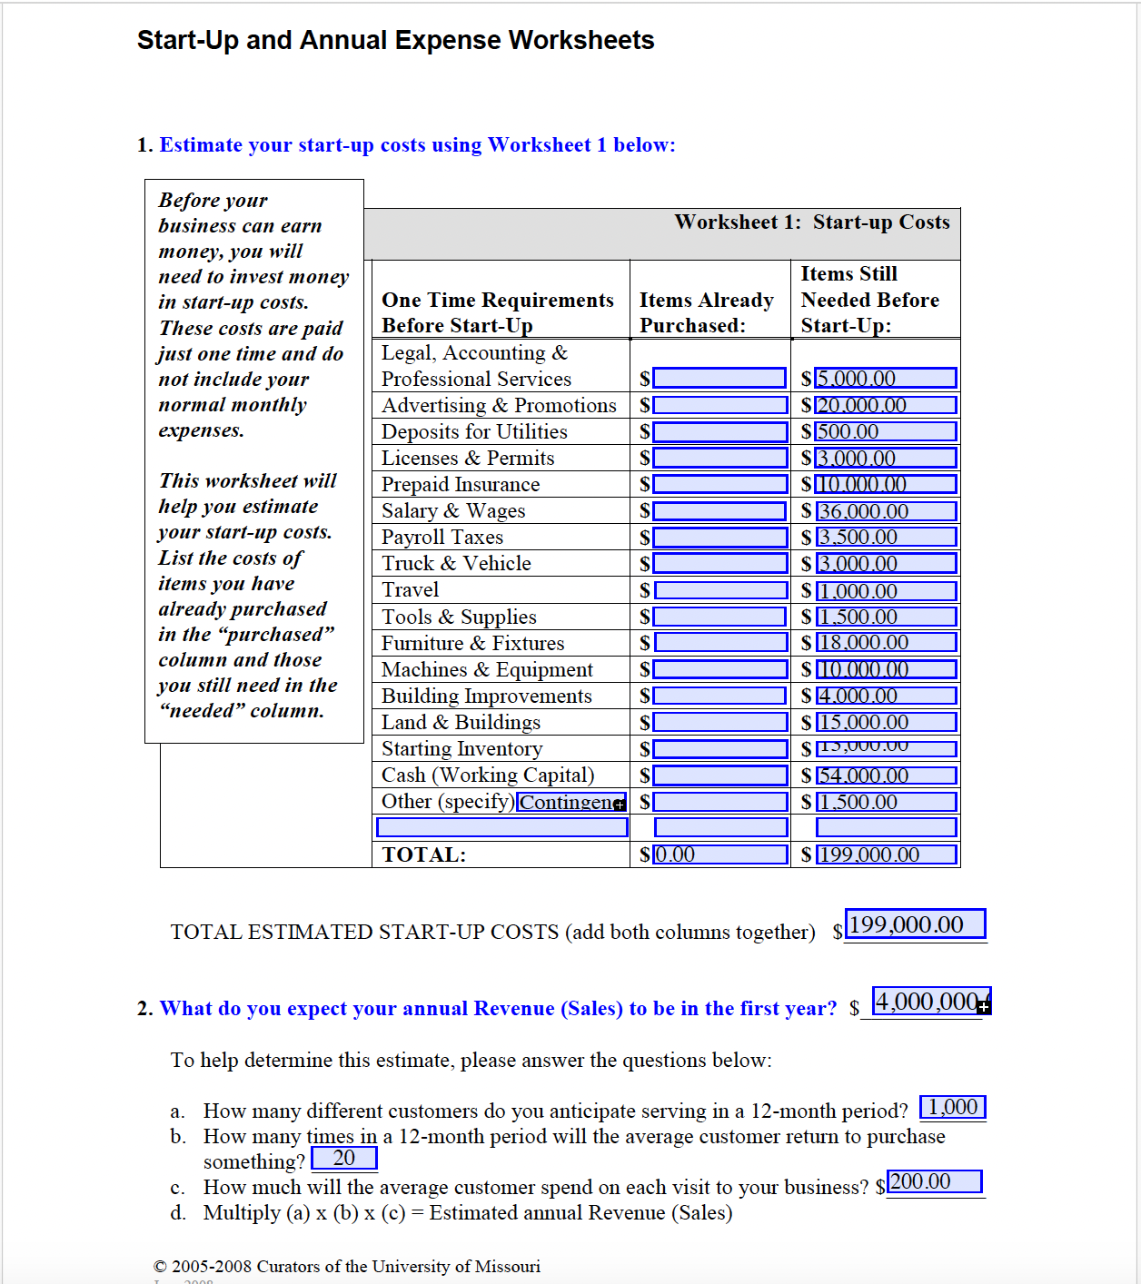

**Appendix K:**

The Annual Sales and Earnings Worksheet is a strategic tool designed to help businesses track, analyze, and forecast revenue and profitability over a one-year period. This appendix provides an overview of its structure and key components.

